VHFC meets the second Friday of each month from
April through November
Location: Manahawkin Community Center
775 East Bay Ave Manahawkin, NJ
Doors open at 6:45; Meeting begins at 7:15 PM
Next meeting: 10 April 2026
PRESIDENT’S MESSAGE
Hello VHFC Members,
It is hard to believe that 2025 is quickly approaching the history books. Just a short time back - at least it seems that way to me - lots of us were waiting for the spring bluefish and bass to arrive in the bay and tog to open for fishing our rocks and jetties. Anyway, in the meantime, enjoy the remaining days of 2025 as you prepare for the holidays. You can still surf fish, pursue stripers if your boat is still in the water or charter locally with any guides still fishing or bottom fish on a head boat up north of us for tog.
Every year I mention that the winter months are a good opportunity to inspect, repair and even replace your fishing tackle. Remove the reels from your rods and clean all the salt and corrosion off. Then clean & lube the reel seat before installing the reel back on your rod. Look closely for damaged or worn guides using a magnifier or by running a piece of fine cloth through them. Determine if your line needs replacing due to age, wear or loss of line. Braid can last several years but still eventually wears out. Worn looking, faded or tattered braid should be replaced. If you have the time and ability, service your own reels or bring them to one of our local tackle shops. They have the time during the winter to do any repairs quickly before the spring rush.
Next, go through your tackle inventory and rediscover all the items you’ve bought over the seasons and could not remember where you stored them due to an age related malady known as CRS - Can’t Remember $#!T. Discard, repair or replace badly rusted hooks and lures. If you have the time and desire, take an emery cloth and black permanent marker to your lure hooks. Another option, buy replacement trebles or single hooks. Not your thing - throw out your old tackle in bad condition and buy new. There are sales everywhere so take advantage and treat yourself to some new equipment. You deserve it but act now before spring is knocking at the door.
Although our next meeting and Newsletter are not until April 2026, VHFC will still be very active at many local fisherman’s flea markets trying to recruit new members. All the dates and events are later in the Newsletter. Our website will still be active through winter and you can submit reports at any time. For those members (myself included) escaping the cold and heading south, a fishing report and photo of your warmer water catch is nice to share with members. Although I will be in Florida from January through March, I will be online and reachable by email, text or cell so do not hesitate to contact me if you need anything.
Lastly, relax and enjoy the upcoming holidays with your family and friends. Stay safe & warm during the winter months and I look forward to seeing everyone next season. Merry Christmas, Happy Hanukkah and Happy Festivus to the rest of us!
Ed
------------------------------------------------------------------------------------
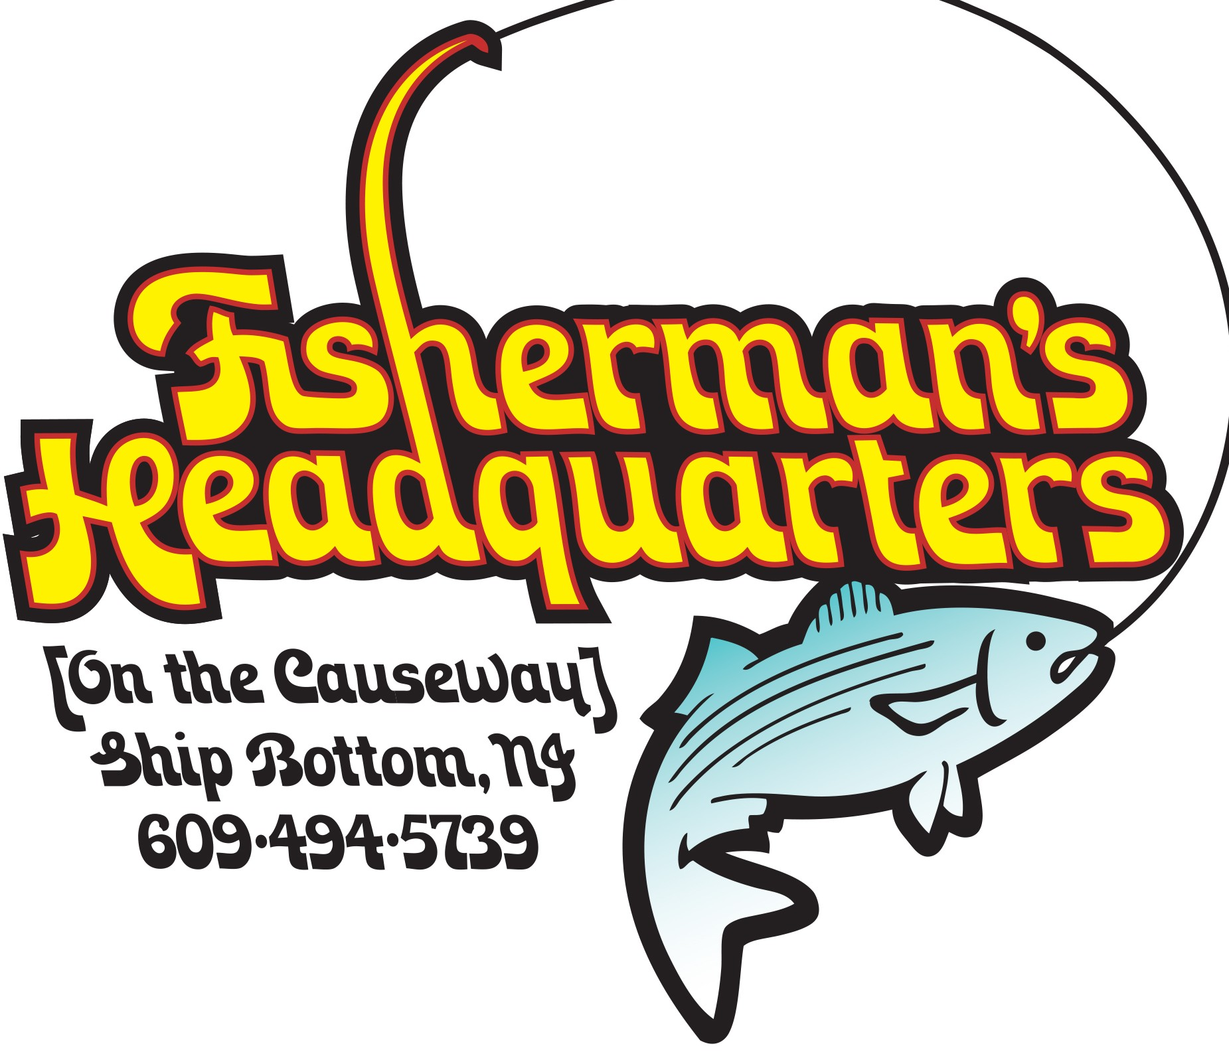
Helping Anglers Catch More Fish Since 1962! Your one-stop destination before your next fishing adventure
‘On The Causeway’
280 W 9th St, Ship Bottom
Visit FHQ 609 494 5739 -------------------------------------------------------------------------------------------------------------
APRIL MEETING - Our next meeting will be at the Community Center on Friday April 10th to kick off the 2026 season and this will be our first pizza meeting! So come on out and enjoy a few slices while getting reacquainted with fellow anglers. Our speakers have not yet been chosen but stay tuned for further details.
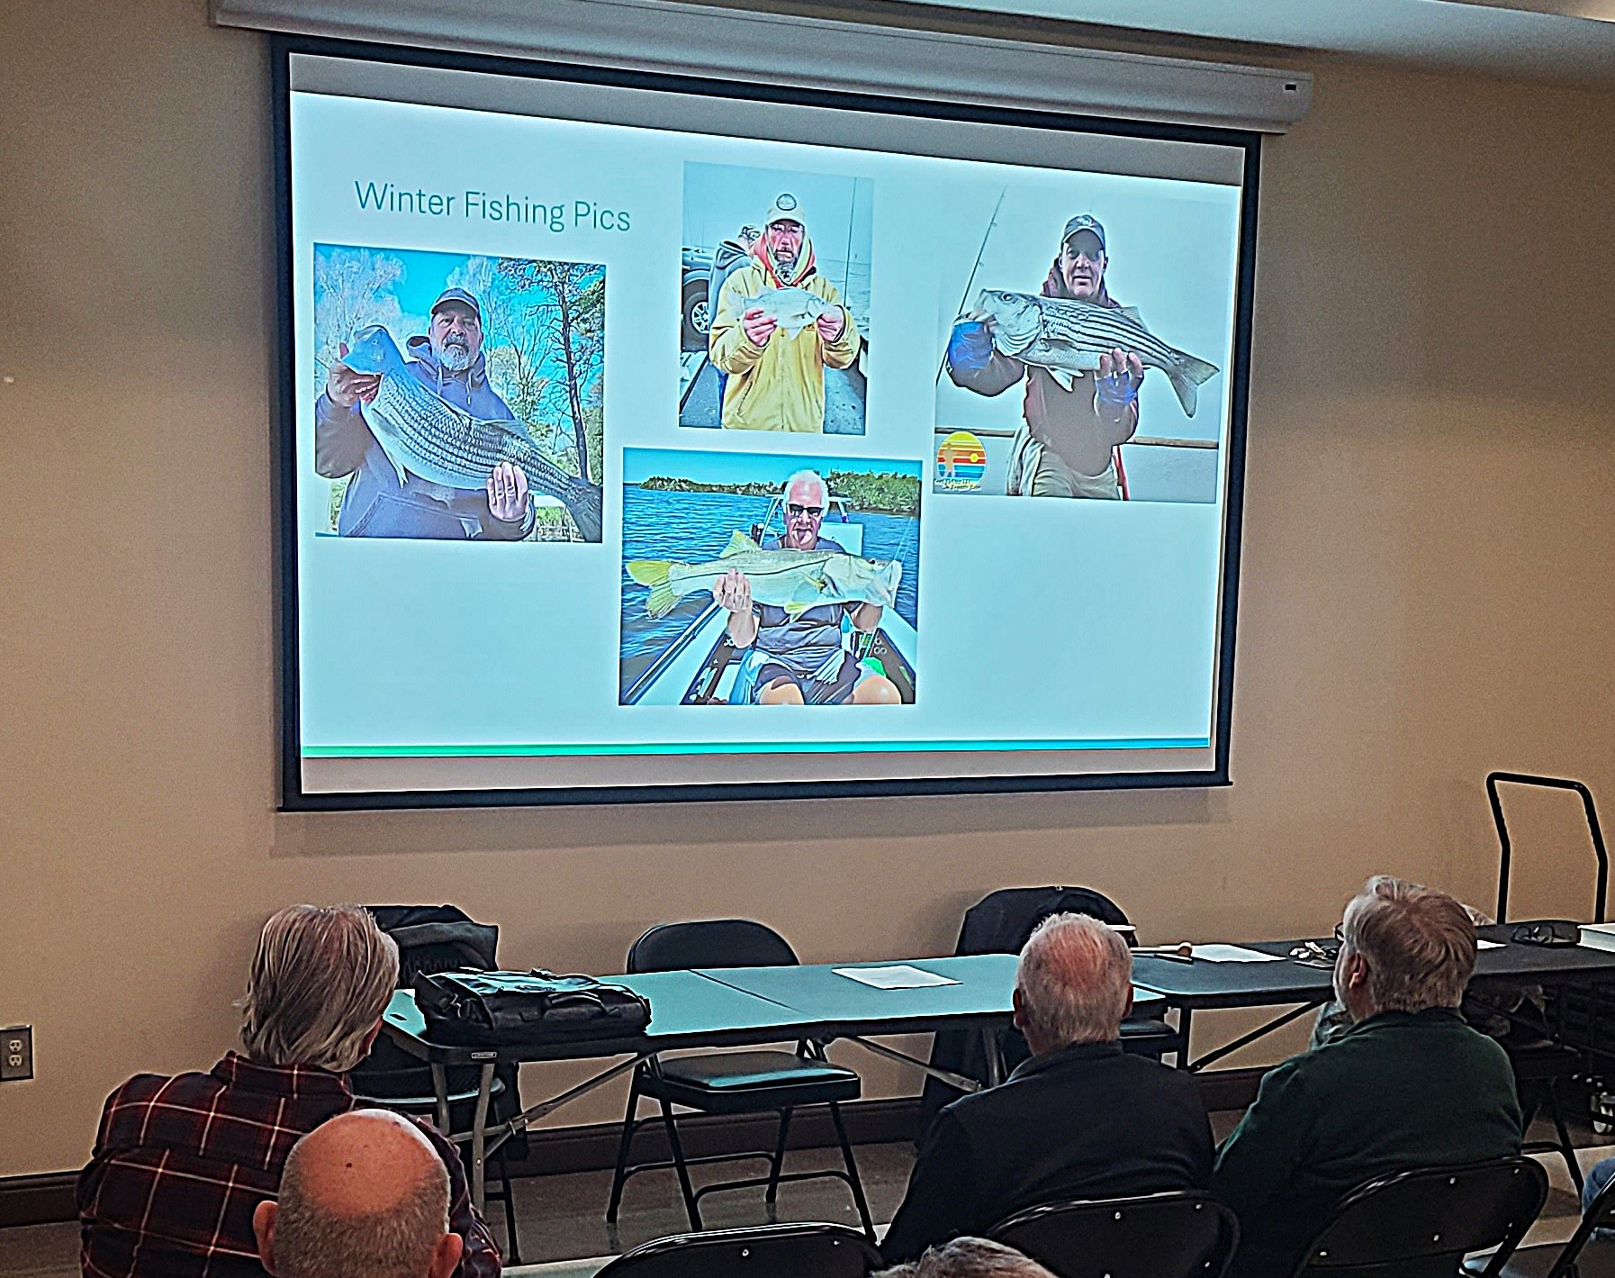
Our November meeting featured Phil Simon’s ‘Year in Review’, a collection of stats, photos and memorable events from 2025.
The slide shown is “Winter Fishing Pics” and features Pat Presutto and Bayside Dave with a Striped Bass, Bill Bond with a White Perch and yours truly with a Florida Snook. Thanks Phil for a great job and fun evening. Pizza was provided for everyone to enjoy.
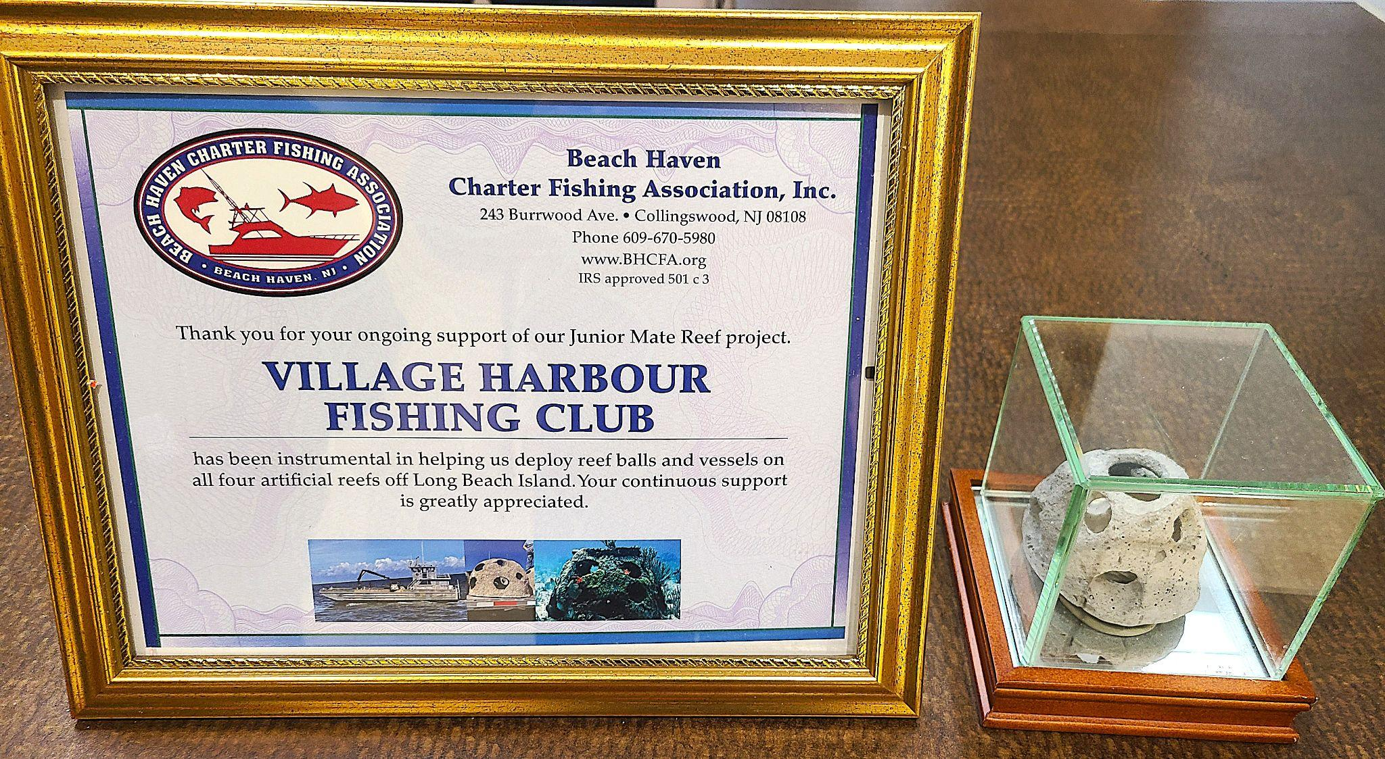
On display at the meeting is the certificate provided by Captain John Lewis acknowledging VHFC’s third and largest donation of $1,000 to the Jr Mate Reef Restoration project.
Thanks Christine Stuebing for providing and framing our award!


-------------------------------------------------------------------------------------------------------------
Home Is Where The Anchor Drops!
Go to Anchor Homes for more information
-------------------------------------------------------------------------------------------------------------------------------
WINTER EVENTS by John Stuebing Although our next meeting is not until next April, there are plenty of events all winter long where you can hang out with fellow VHFC Members.
January 18 – Lacey Township High School Fishing Club will hold its Fishing Flea Market at the High School Gymnasium. This will be our first year recruiting at this event. I went to this event last year and it is a great flea market. Stop by to say hello and shop for some great bargains. The show runs from 9AM to 2PM.
January 25 – Sunshine Foundation Fishing Flea Market VHFC will have a table at this event held at the Edward Thornton Community Center in Little Egg Harbor. The event runs from 8:00 – 1:00. Chuck DIshian and I will be at the event recruiting new members. Stop by to lend a hand or just say hello.
February 7 – Southern Regional Fishing Flea Market We always attend this show and 2026 will be no exception. The event is always packed with vendors with lots of tackle at great prices. Chuck and I will need help with this one. Try to attend and give us a hand. This is also a great opportunity to renew your membership.
February 14 – Canyon Runner Offshore Seminar This is an all-day event at Harrah’s in Atlantic City. I have been going to this event for years. If you fish offshore, this event is a must. Jerry and I will be attending the event and will carpool with anyone who wants to join us. More information and tickets are available on line. What better way to spend Valentine;s Day!
February 26 – March 1 – Atlantic City Boat Show. In the past, some members get together on the Friday of the show and car pool to AC. If you are interested in joining us, let me know.
March 13 – 15 – New Jersey Saltwater Expo The biggest fishing show in New Jersey. Most likely several members will carpool on Friday the 13th to the show in Edison, NJ. Let me know if you are interested in making the trip.
April 4 – The Boat Shop Open House Always our biggest recruiting event of the year. Great deals on boating supplies with giveaways, snacks and chances to win prizes. We need all the help we can get with this one. Mark your calendar and join us at this event. 9:00 AM start time.
UPCOMING VHFC 2026 EVENTS - For your long term planning and participation.
- January 18 Lacey Township High School Fishing Club
- January 25 Sunshine Foundation Fishing Flea Market
- February 7 Southern Regional Fishing Flea Market
- February 14 Canyon Runner Offshore Seminar
- February 26 - March 1 Atlantic City Boat Show
- March 13 - 15 New Jersey Saltwater Expo
- April 4 The Boat Shop Open House
- April 6 First Newsletter for 2026
- April 11 First Meeting for 2026
- Inshore Slam May 25 - 31
- July 12 VHFC Fluke Tournament & BBQ (July 13 rain date)
- July 25/26 Tri Club Fluke Tournament and BBQ (26)
- VHFC Open - August 24 - 30
-------------------------------------------------------------------------------------

Complete Website Design with web hosting and domain names.
Merchant services with low-cost credit card processing options.

Pack and Ship Store, FedEx, UPS, and USPS

Free Website and Merchant Services Review.
Visit Web 2.0 Business Center
-------------------------------------------------------------------------------------
NEW JERSEY REGULATORY NEWS by Phil Simon - On December 16 and 17, the Mid-Atlantic Fishery Management Council (MAFMC) will take up the issue of recreational measures, i.e. our harvest amounts, for Summer Flounder, Scup, and Black Sea Bass. In August the MAFMC Science and Statistics Committee (SSC) issued its Allowable Biological Catch (ABC) for all three, and everyone celebrated the fact that healthy increases were established. These numbers are then split between the recreational and commercial sectors according to established allocations.

In the old days, meaning four years ago, these numbers would see some further minor adjustments, and then the final coastwide commercial quotas and recreational harvest limits (RHLs) would be set and state numbers would be sent out to the individual state councils. For the commercial side, this is what is happening, and they will be looking at increases across the board. For us, not so much, because the MAFMC (and the Atlantic States Marine Fishery Commission) implemented a so-called “harvest control rule”, termed the Percent Change Approach, that takes the RHLs and sends them through yet another decision tree.

The intent of this additional step, when introduced, was to smooth out the changes from year to year so that we weren’t surprised with a sudden increase or decrease. But as it turned out, the Percent Change Approach is ultraconservative, increases never seemed to materialize, and decreases were called for more often than not. So even though SSC raised the ABC’s, some by more than 40%, the recommendations from the staff at the MAFMC are for status quo for all three species for 2026. For Black Sea Bass, where the stock is approaching three times its target level, this is absurd. I discovered at the last meeting of the Summer Flounder, Scup, and Black Sea Bass Advisory Panel (of which I am a member), a small change in one of the parameters used in the calculations for Black Sea Bass completely flipped the outcome from status quo to 39% liberalization.

(For the wonky among you, this was a change in the Confidence Level Percentage, which is then used to calculate the Confidence Interval, which is used to” bin” the projected harvest into a particular category of regulatory changes. This Confidence Level was experimentally changed from 80% to 75%, which narrowed the Confidence Interval, which was now narrow enough to exclude the harvest forecast from the “no liberalization” bin all the way to the maximum liberalization bin. Got that?) (I have seen a similar analysis done for Scup or Summer Flounder so far.)

With this amount of fluidity in the model, the Percent Change Approach is clearly unacceptable as a decision-making tool for determining the ups and downs of recreational harvest numbers. And of course, we still have major problems with the numbers spit out by the Marine Recreational Information Program (MRIP), which has been over-estimating recreational catch numbers by 30% or more since the “New MRIP” was implemented in 2018. These numbers also play a huge role in the calculations used in the Percent Change Approach. It will be interesting to see how the council members deal with all of this, or if NOAA will (again) have to intervene with some common sense. For those of you who want to observe the MAFMC meeting online, details on how to connect, as well as the agenda and briefing materials, go to https://www.mafmc.org/briefing/december-2025 .

--------------------------------------------------------------------------------------------------------------------
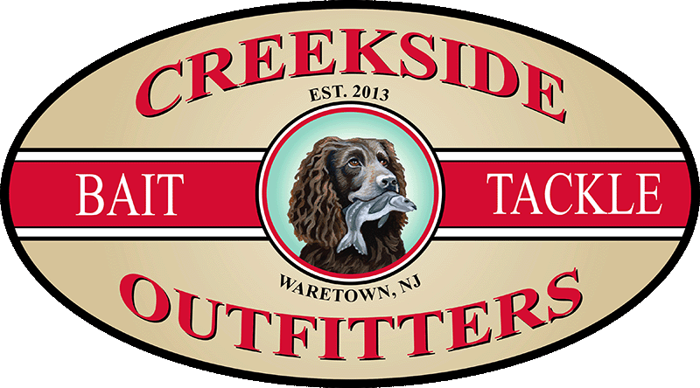
Family owned and operated, Creekside Outfitters delivers premier customer services, quality products, and fair pricing. 403 Rte 9, Waretown, NJ
--------------------------------------------------------------------------------------------------------------
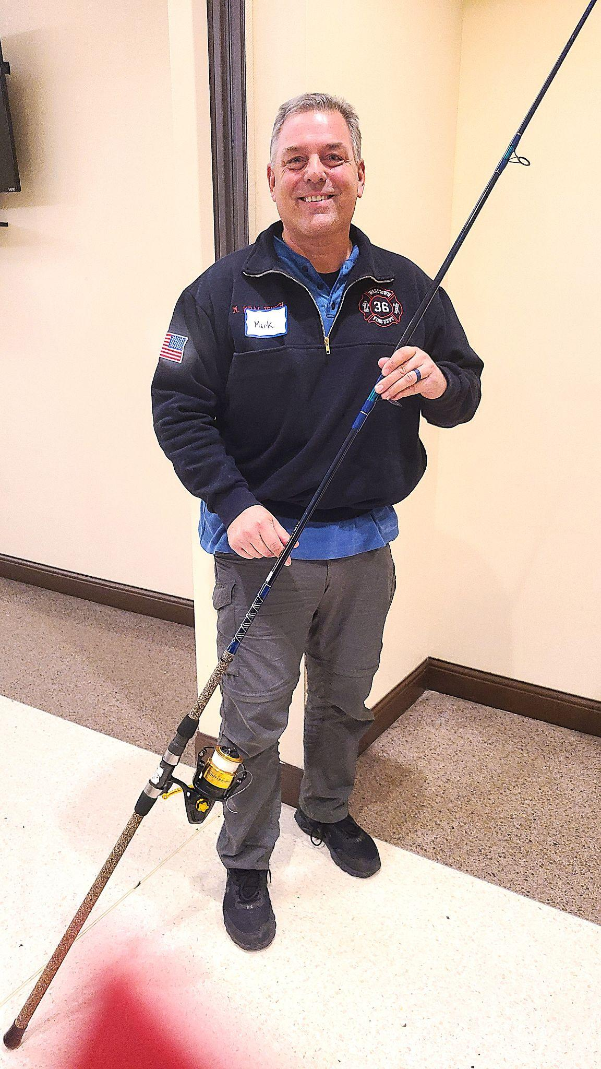
ROD n’ REEL RAFFLE by Ed Valitutto - .

Our third and final rod n’ reel raffle was held at our November meeting. Winner Mark Kraljevich is all smiles holding his new Tica Dolphin Surf Fast Action 10’ MH rod with a Penn Spinfisher 6500 V reel. Later on during the meeting, Mark also won the 50 /50 raffle!

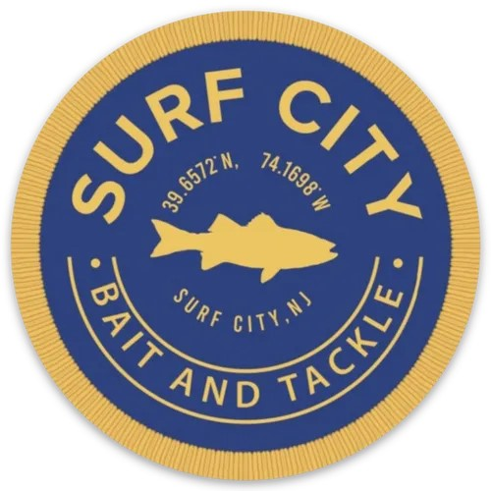
------------------------------------------------------------------------------------------------------------
Your Source on LBI For 317 Long Beach Blvd, Surf City
Quality Bait & Tackle Surf City B&T
--------------------------------------------------------------------------------------------------------------
NOVEMBER POM RAFFLE WINNER by Jerry Nichols & Phil Simon - At the November meeting, each prior month’s winner received one chance to win a $50 gift award. Tim Naples was the lucky winner and received the award.
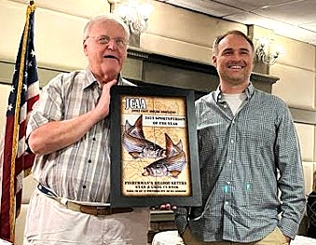
JCAA SPORTSMEN of the YEAR by Ed Valitutto The photos below were taken at the JCAA Sportsmen of the Year dinner at the Captain's Inn on Saturday November 8th.

This year's very deserving winners were the father & son team of Stan and Greg Cudnik of Fishermans Headquarters nominated by VHFC!

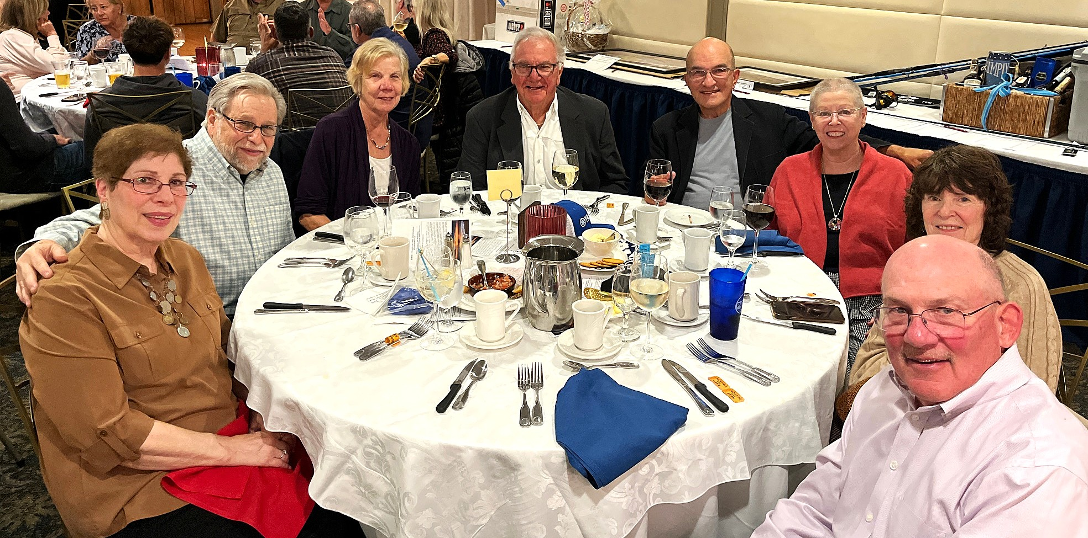
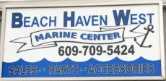
VHFC Members attending starting from the left: Susan & Phil Simon, Pat & Ed Valitutto, Chuck & Ellen Dishian and Christine & John Stuebing. Everyone bought their own tickets. -------------------------------------------------------------------------------------------------------------
A Full Service Boating and Fishing Store Serving Manahawkin, LBI and Barnegat Bay
Visit BHW Marine Center

--------------------------------------------------------------------------------------------------------------
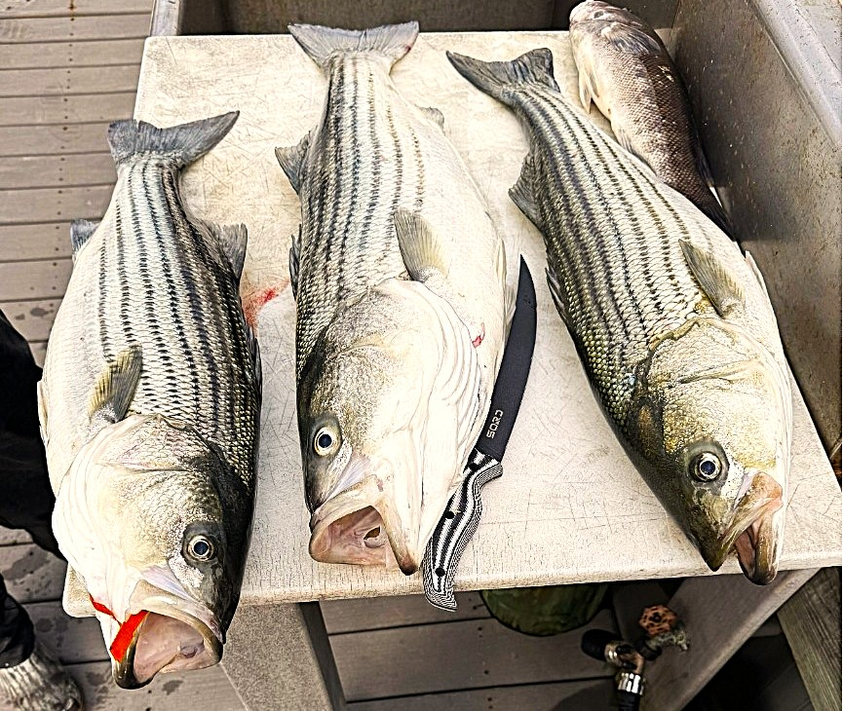
SOCIAL MEDIA by Bayside Dave Etelman - Our VHFC sites are VHFC FB Site and VHFC Instagram . The FB site has 225 followers with 122 Likes with each post reaching thousands of people; our Instagram account has 298 followers. Dave shares Members Reports, club activities, monthly meetings as well as tips for fishing and boating on both social media networks. It’s important to Like and Comment on each post to help boost distribution. Here’s a recent post from the Leary clan aboard the Jen-Jen

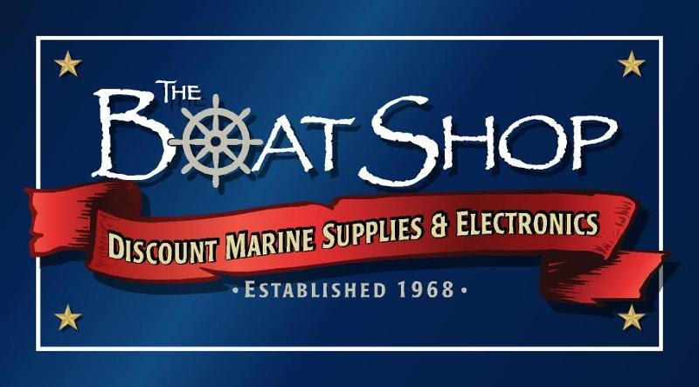
After catching a few Tog, the Jen-Jen headed up the IBSP beaches where there were large schools of sand eels and plenty of bass. They kept two plus a slot and released many others. ----------------------------------------------------------------------------------- For All Your Boating Needs
GO TO The Boat Shop
756 East Bay Avenue, Manahawkin
---------------------------------------------------------------------------------------------
FALL DINNER by Ed Valitutto - Club members had a fantastic evening at Kostas Grill in Tuckerton. Bill Dabney did his usual outstanding job coordinating the dinner and providing an assortment of fine wines to cover appetizers right through to desert. This year, Bill had the wines numbered and he provided a description of each for members to enjoy and remember which bottle they especially liked. Owner Gus (in Greek it’s Kostas). provided platters of delicious appetizers and plates of fried calamari that were enjoyed by everyone. Appetizers and wines were provided by VHFC so be sure not to miss next year’s dinner. Check out the photos on the following page.

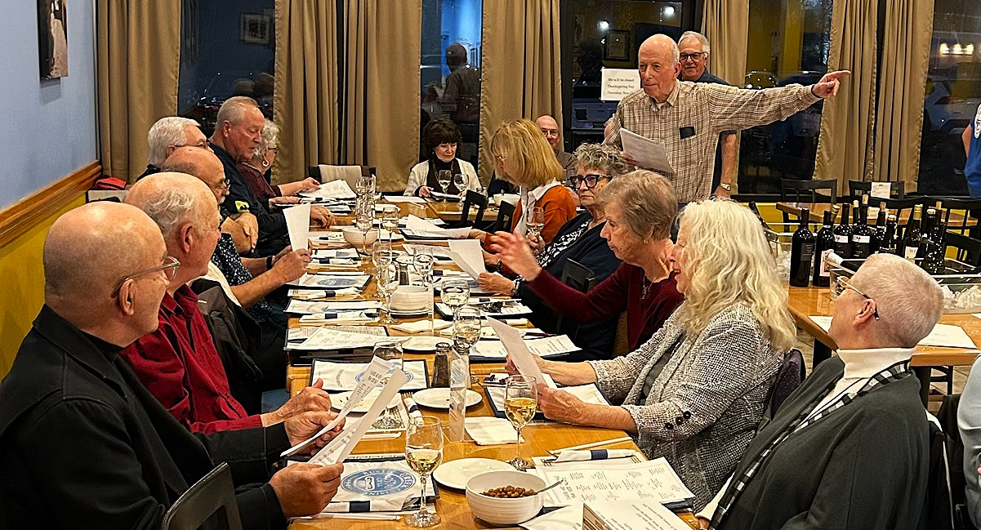
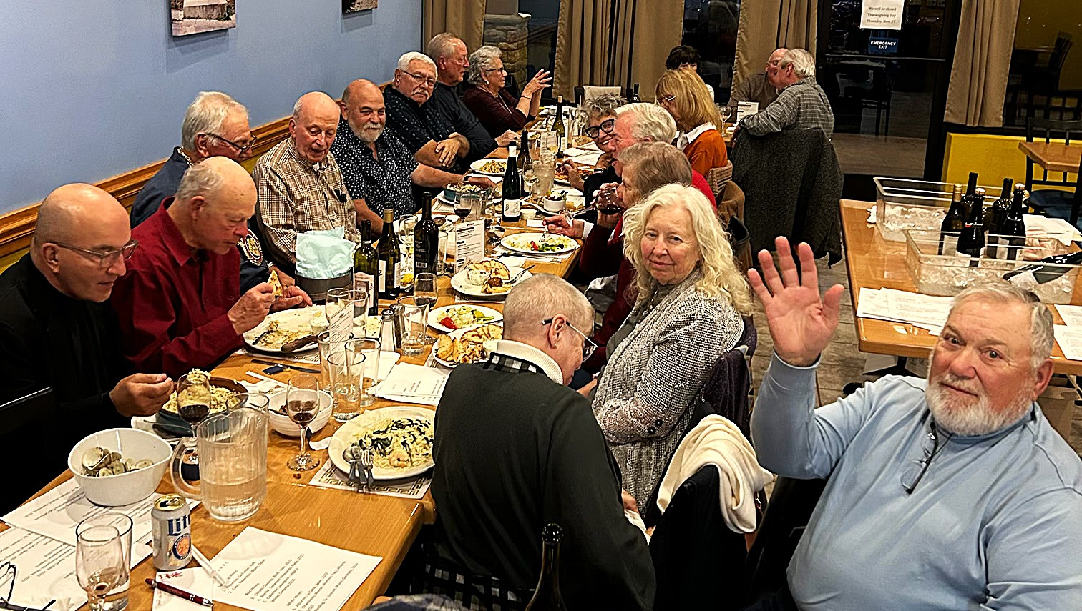
That’s Bill Dabney reading the wine descriptions to a thirsty group!
There’s a happy group enjoying their dinner and wine!
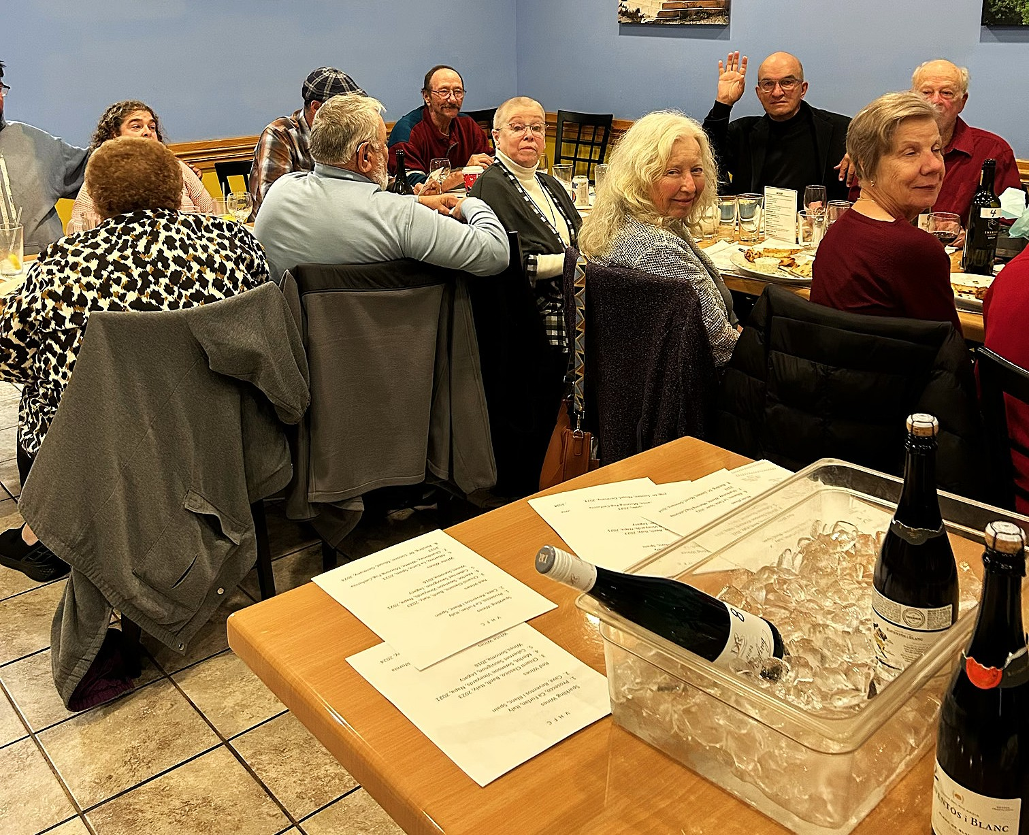

Another view of folks along with the white and bubbly wines on ice.

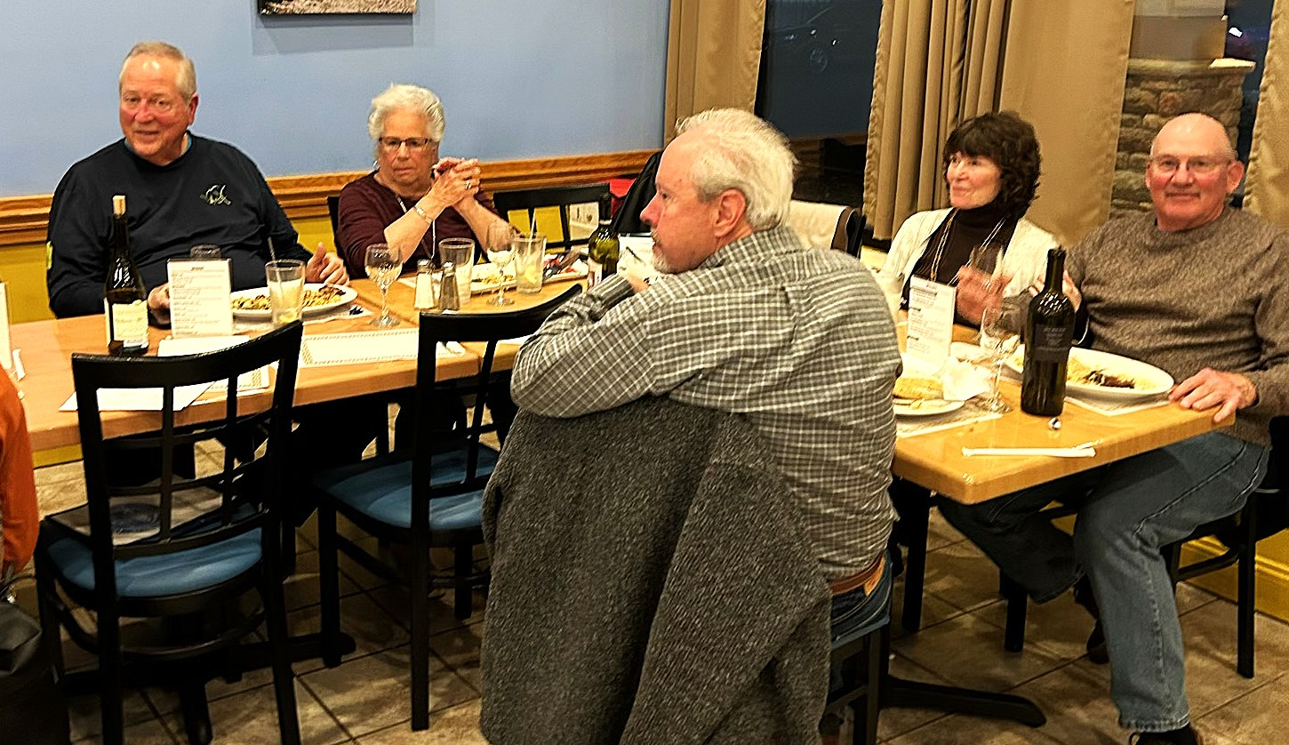
The other end of the table shows Larry & Laura Leary, John & Chris Stuebing and Jerry Nichols.

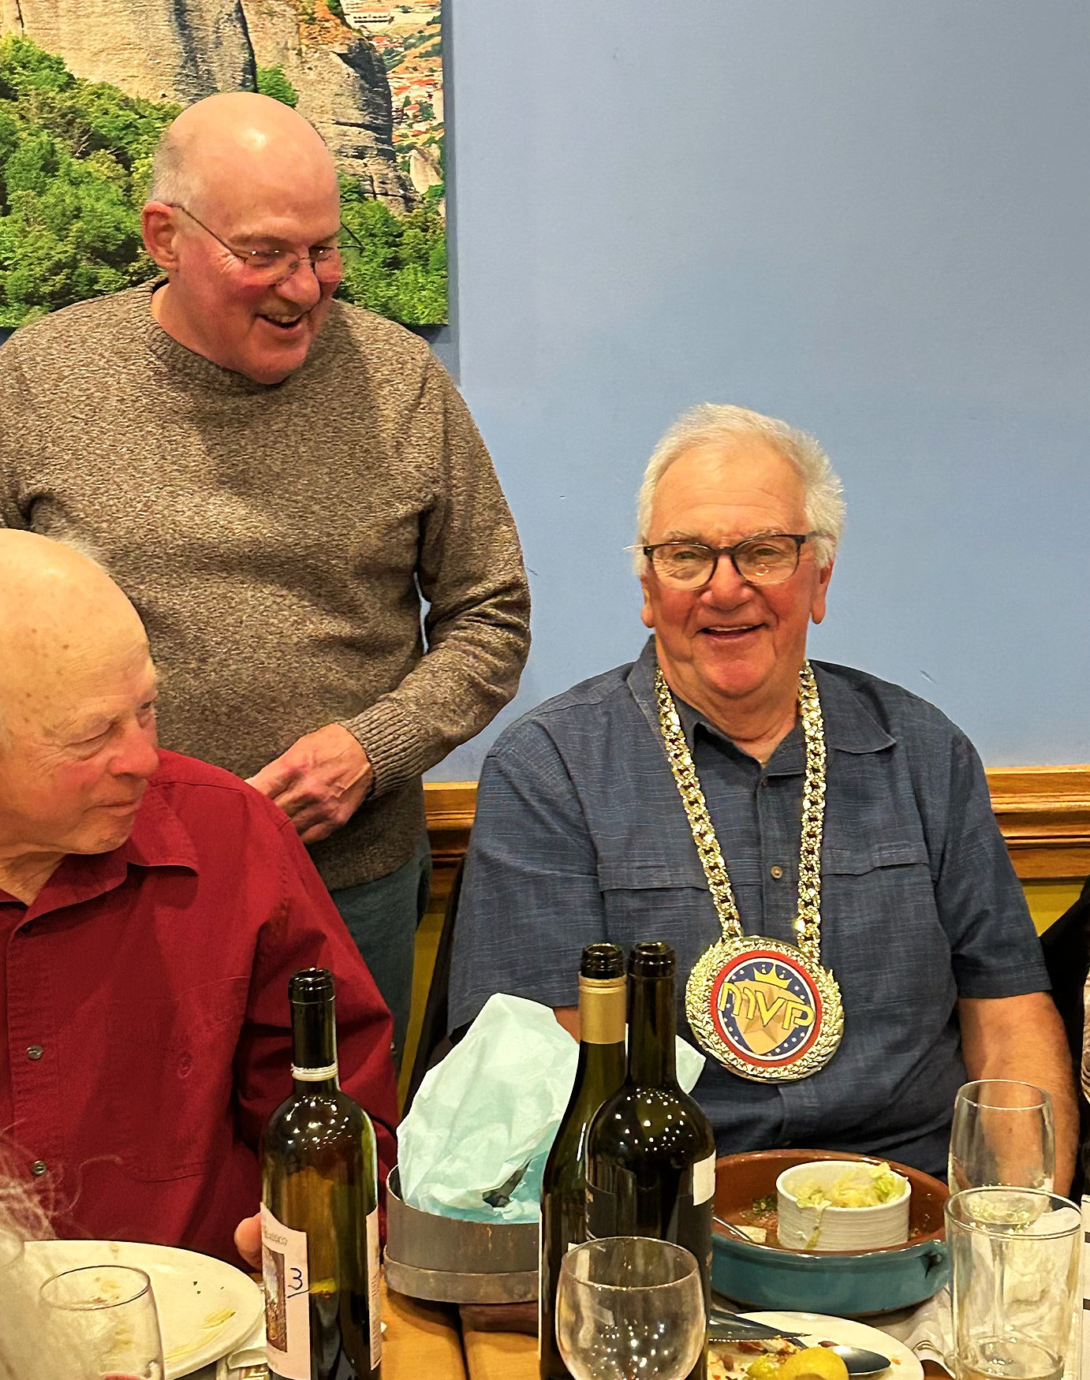

That’s yours truly (Ed V) after being presented an MVP medallion for some unknown reason. I will wear it to the next club meeting for all to see.

---------------------------------------------------------------------------------------------------------------------

Martek Marine Electronics is a full service marine electronics equipment dealer.
We can help you decide on the best piece of equipment to suit your needs. We provide sales, service, and installation. Visit Martek
----------------------------------------------------------------------------------------------------------------------
VOLUNTEERS NEEDED - by Chuck Dishian The Jersey Coast Anglers Association will be setting up booths at two events early next year. They will be at the Atlantic City Boat Show from February 25 – March 1 and the NJ Saltwater Expo in Edison from March 13 – 15. They’re looking for volunteers to man the booths. Responsibilities will include selling raffle tickets, handing out informational pamphlets and providing general information in 4 hour shifts. Volunteers will be granted free admission to each event, so you show up for free, sell a few raffle tickets and get to enjoy the shows once your shift is over.
If you’re interested, please contact Chuck Dishian at cdishian@yahoo.com or 914-439-6244.
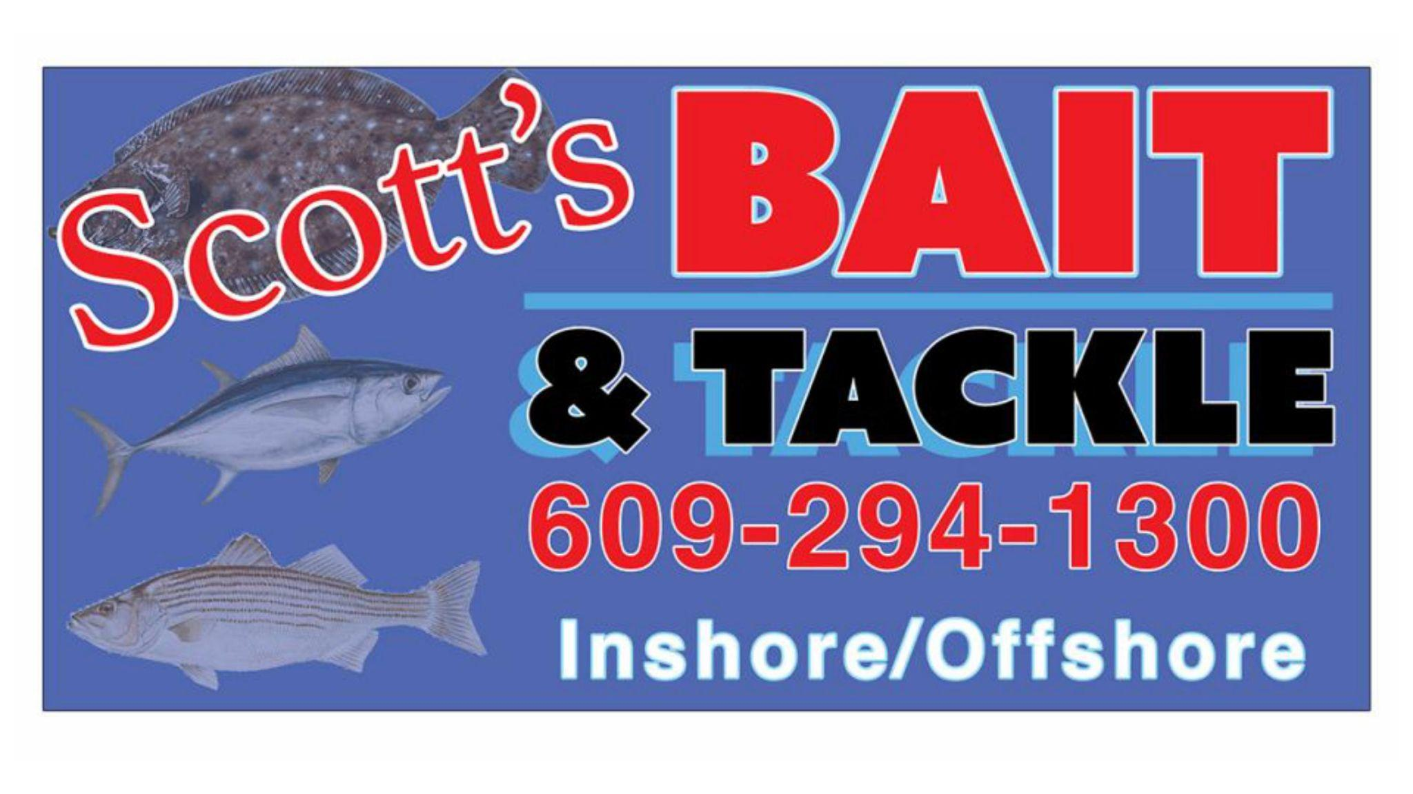
------------------------------------------------------------------------------------
For all your Bait & Tackle needs, visit
Scott’s Bait & Tackle in Tuckerton
Scott's -------------------------------------------------------------------------------------
PRESIDENT’S 2025 FISHING ASSESSMENT by Ed Valitutto This is how I saw 2025 fishing in our area based on my personal experience, members’ reports and FOM submittals. If you did much better, more power to you! If you didn’t do as well, sorry to hear it but that’s fishing! I would rate 2025 as just ‘okay’. The weather also didn’t help with the non-stop winds. Weather forced the cancellation of our Tri-Club Fluke Tournament, our summer Fluke outing and disrupted our fall bottom trip three times!
BLUEFISH - Another tough year with few entries. The best chance for Blues was in the inlet. Too bad because I enjoy catching the ‘yellow eyed demons’ and eating them as well!
WEAKFISH - Horrible year with not one FOM entry. A 13” Weakie would win a $50 award! Not many folks target them but usually hook one while Fluking.
BLACKFISH - Very good year for Tog with many decent catches including Marty’s 25” beauty released for another day! I didn’t get as many keepers off the BL docks as last year but I saw plenty of keepers caught. Wrecks and the north jetty were excellent.
SEA BASS - Excellent year with many limits caught especially in the spring. After the first few weeks, you had to search and fish hard for keepers. Fall was tougher with the nasty winds keeping folks home but still a very good year.
BLOWFISH - Very slow year with hardly any entries. Also, very few complaints from anglers regarding hordes of Blowfish biting the tails off Gulp while out Fluking.
STRIPED BASS - This was feast or famine. Spring fishing was better than the fall run. The bass are still heading south and must travel past our area but when and will they be within the three mile line? No bass were caught off the sands for the fall season - Pat P and Bill Bond tried real hard as did 13 members fishing the Surf Tournament - and the leading fall “over’ Striper is my paltry 38” entry. But it’s not over yet!
FLUKE - Excellent year with 11 Fluke over 24” entered for FOMs! I didn’t hear much complaining about having to catch 20 - 30 shorts for one keeper. I also think the technique explained by Greg Cudnik at our meeting regarding anchoring - preferably via a trolling motor - at a wreck and jigging. If no bites happen then move 5 feet. This definitely works and is contrary to the normal drifting technique for Fluke. Fluking the surf was better in the spring. The fall FOM did not get an entry!
TUNA - Yellowfin were caught by Tim Naples and Bayside Dave but they traveled long distances. The Bluefin season was officially closed mid season and yet there were several around close to shore in the fall. Oh well! Hopefully BFT will reopen in 2026.
DOGFISH & SKATES - Plenty for everyone. Sleep well, knowing the stock is in great shape! Off the beach or in the ocean all year long, Dogs and Skates were there for you.

------------------------------------------------------------------------------------------------------------------
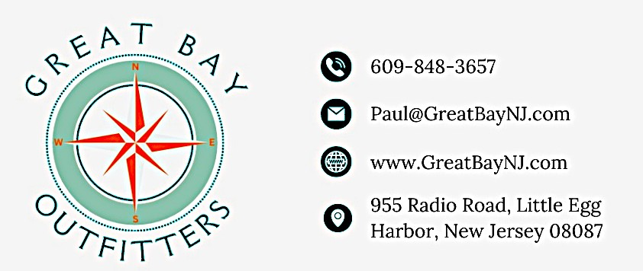

Kayak sales, rentals, accessories, rigging and repairs as well as bicycle and e-bike sales and repair. Discounts of 5% -10% for VHFC

------------------------------------------------------------------------------------------------------------------
VHFC SURF FISHING TOURNAMENT & BBQ by Bayside Dave Thirteen club members got up early to surf fish the LBI sands. The tournament was purposely moved to November in the hope that the Bass would be here. They were not! The only catches were Skates and Dogfish. Dave managed a Hickory Shad on a teaser but that was released. The weather was seasonably cold and unfortunately it rained through the first few hours. Back at Surf City Bait & Tackle, the burgers were delicious! The prize money was raffled off with Ed Begley and Mark Kraljevich - the same guy who won the rod raffle and the 50/50 the night before - were the winners. Still a fun time for everyone. Thank you Tom Santaguida for hosting!
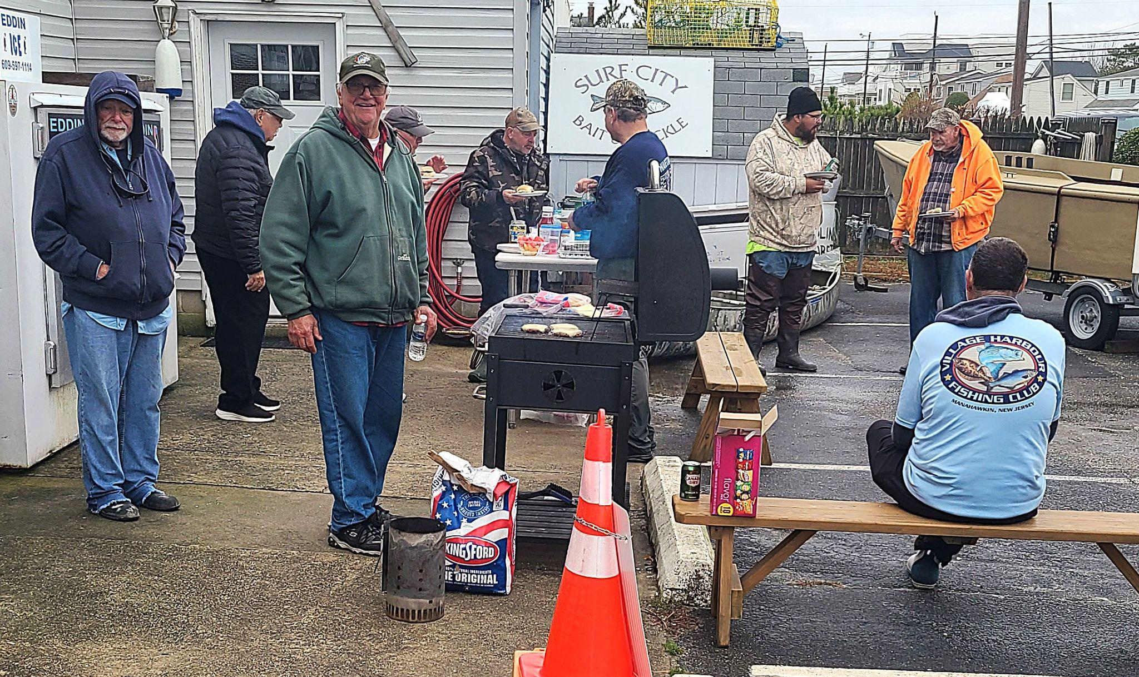
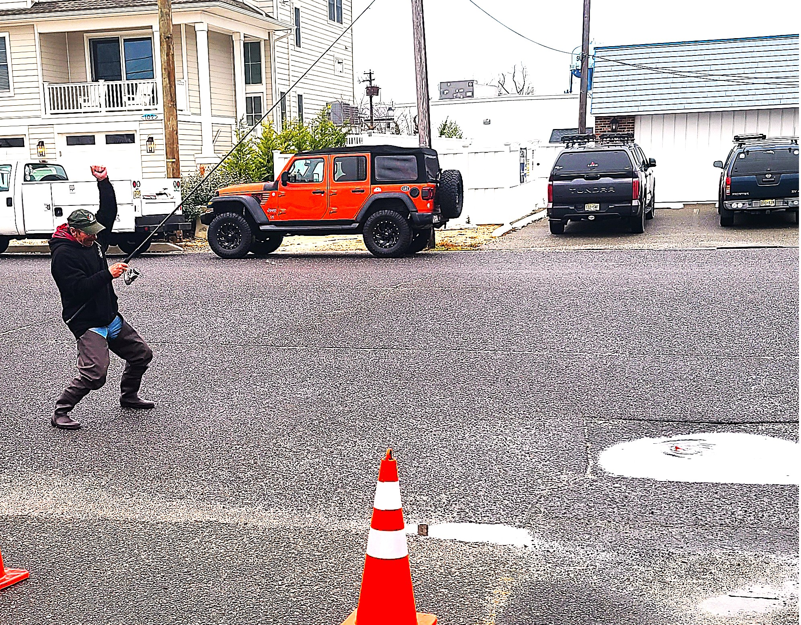

After catching squat on the beach, Bill 006 ¾ Bond heard the Bass were in real close. Despite his best efforts, the prizes were raffled off! BTW, it was rumored that magic brownies provided by Karen Etelman were involved!
2025 FOM ENTRIES - Here’s our list of 2025 entries since the last Newsletter. Go to 2025 FOM Entries for the list of all entries and contest standings.
Angler Species Category Date Size MBA Location
Pts
Alexa Figley | White Perch | Boat | November | 14 | 9.5 |  | Mullica River
Perry Hoagey | Blackfish | Boat | November | 15 | 18 | 4 | LER
Marty Friedrich | Blackfish | Boat | November | 15 | 25 | 10 | LER

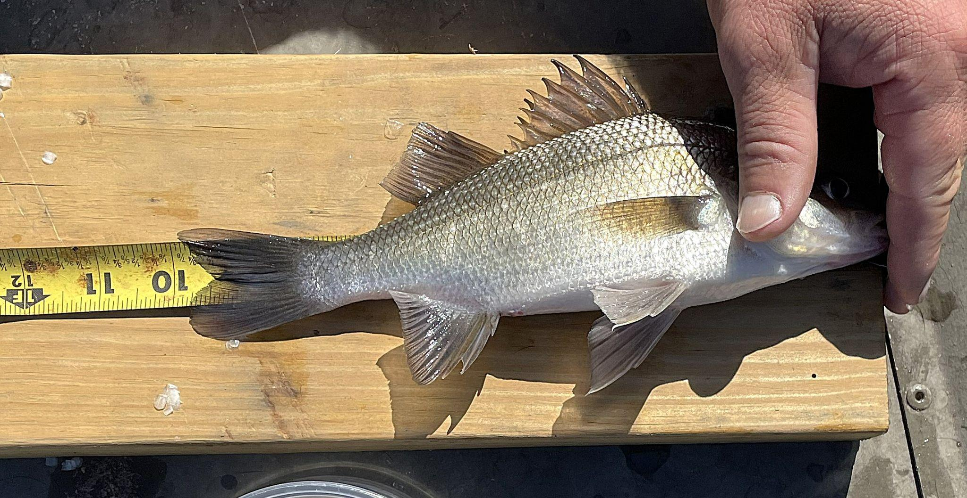
Here are a few photos of some November entries:

That’s Alexa Figley”s White Perch that leads the Jr Angler category. Nice fish Alexa!

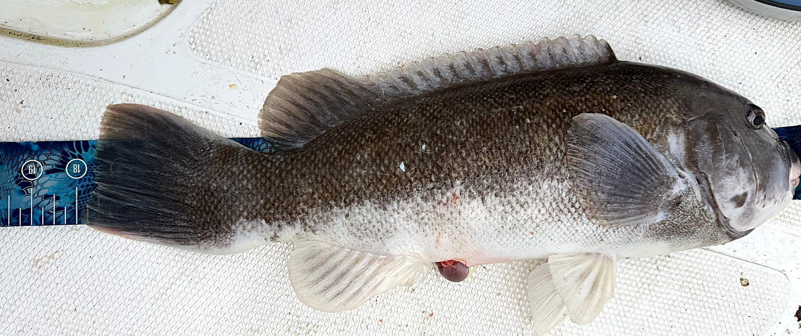
That’s a nice 18” Tog Perry Hoagey got when out with Marty when he caught his beast!

FISH of the MONTH (FOM) - The largest fish caught during the specified period will be awarded a $50 gift certificate to a local tackle shop. For 2025, there are 34 FOM Adult awards and 7 Junior Angler awards each for a $50 certificate..
8 FOMs closed in November:
2 Jr Angler Awards
Kingfish Alexa Figley 10.5
Blowfish No Winner

6 Adult Awards

Triggerfish Glen Minor 17.25
Blowfish Dave Puzak 8.25
Kingfish Perry Hoagey 13.5
Yellowfin Tim Naples 45.
Mahi Mahi Glen Minor 34.
False Albacore No Winner
Congratulations to all the winners!
There are 4 Junior Angler and 12 Adult contests open - 4 Surf, 6 Boat, 2 Boat or Surf & 0 Offshore. All remaining 16 awards close on 31 December.
Open contests are shaded Green. Closed contests are shaded Red.
Junior Angler Awards
Species Start Finish Leader / Winner Size
White Perch 3/1/25 12/31/25 Alexa Figley 9.5
Bluefish 3/1/25 12/31/25 Mallory and Alexa Figley 14.5
Kingfish 3/1/25 11/30/25 Alexa Figley 10.5
Blowfish 3/1/25 11/30/25 TBD
Fluke 5/4/25 9/25/25 Bryson Wyatt & Mallory Figley 22.25
Sea Bass 5/17/25 12/31/25 Bryson Wyatt & Alexa Figley 15.25
Striped Bass 3/1/25 12/31/25 TBD
Surf FOM
Species Start Finish Leader / Winner Size
Striper 3/1/25 7/31/25 Pat Presutto 30.875
Striper 8/1/25 12/31/25 TBD
Striper Over 31” 3/1/25 12/31/25 Tom Godfrey 44.5
Bluefish 3/1/25 6/30/25 Pat Presutto 30.25
Bluefish 7/1/25 12/31/25 Dave Etelman 20
Fluke 5/4/25 6/30/25 Pat Presutto 22
Fluke 7/1/25 9/25/25 No Entry
Blackfish 4/1/25 4/30/25 Mike Woodrow 15.25
Blackfish 8/1/25 12/31/25 Tom Godfrey 18.75
2025 Boat FOM Leaders
Species Start Finish Leader / Winner Size
Striper 3/1/25 7/31/25 Drew Kraycirik 26.5
Striper 8/1/25 12/31/25 Drew Kraycirik 31
Striper Over 31” 3/1/25 12/31/25 Ed Valitutto 38
Bluefish 3/1/25 6/30/25 Jim Healy 20.75
Bluefish 7/1/25 12/31/25 Mike Woodrow 26
Blackfish 4/1/25 4/30/25 Bert Kern 17.5
Blackfish 8/1/25 12/31/25 Drew Kraycirik 18.75
Sea Bass 5/17/25 6/19/25 Marty Friedrich 19.5
Sea Bass 7/1/25 8/31/25 Drew Kraycirik 17.5
Sea Bass 10/1/25 12/31/25 Paul Pinatelli 20
Triggerfish 5/1/25 11/30/25 Glen Minor 17.25
Porgy 5/1/25 12/31/25 Dave Etelman/Dave Puzak 15
Fluke 5/4/25 6/30/25 Cheri Hebert 26.5
Fluke 7/1/25 7/31/25 Ron Nachman 26.25
Fluke 8/1/25 8/31/25 Tim Naples 25.25
Fluke 9/1/25 9/25/24 Perry Hoagey 27
Weakfish 4/1/25 10/31/25 No Winner
2025 Boat or Surf FOM Leaders
Species Start Finish Leader / Winner Size
White Perch 3/1/25 12/31/25 Dave Spendriff 13
Blowfish 3/1/25 11/30/25 Dave Puzak 8.25
Kingfish 3/1/25 11/30/25 Perry Hoagey 13.5
Black Drum 3/1/25 12/31/25 Tyler Leary/Tom Godfrey 39
2025 Offshore FOM Leaders
Species Start Finish Leader / Winner Size
Bluefin 5/1/25 11/30/25 No Entry
Yellowfin 5/1/25 11/30/25 Tim Naples 45
Mahi 5/1/25 11/30/25 Glen Minor 34
False Albacore 9/1/25 11/30/25 No Winner

2025 Melanie Boytos Award (MBA) Point Leaders (Top 10 Shown)
Angler | MBA Points
Marty Friedrich | 18
Tom Godfrey | 16
Ed Valitutto | 16
Perry Hoagey | 15
Pat Presutto | 13
Tim Naples | 12
Paul Pintinalli | 11
Bill Bond | 10
Drew Kraycirik | 10
Mike Woodrow | 9

2025 Fish of the Year Leaders
Bluefish Pat Presutto 30”
Fluke Perry Hoagey 27”
Sea Bass Paul Pinatelli 20”
Striped Bass Tom Godfrey 44.5”
Weakfish No Winner
Blackfish Drew Kraycirik / Tom Godfrey 18.75”

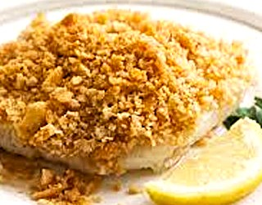
EASY CRACKER TOPPED BAKED FISH by Ed Valitutto This is one of my favorite recipes and it is my Go To for holiday gatherings because it is simple yet delicious. I have made this with Striper, Tog, Fluke and Cod. For Thanksgiving and Christmas, I have the dish prepared and ready for the oven. Once the turkey or Christmas beef is done and resting, put this in the oven while you prepare the other side dishes. As of now, if I don’t get a Striper, I will be making this with Costco Cod for Christmas!

Ingredients

1 to 1 1/2 lbs any firm white fish like Cod, Striper or Tog

2 tablespoons butter melted or olive oil

2 tablespoons chopped parsley

1 sleeve Ritz crackers or a generous cup of bread crumbs

Optional 1-2 cloves garlic minced or 1/4 teaspoon garlic powder
Grated rind of a lemon
Mayo for brushing on the fish
Splash of white wine

Salt and pepper

Directions
- Preheat your oven to 375 degrees and coat a baking dish with cooking spray or olive oil or butter.
- Mix parsley into the softened butter with lemon rind and garlic if using, then crush the crackers in their sleeve and mix together with the butter.
- Pat the fillets dry and arrange in the baking dish. Season each fillet with salt and black pepper on both sides. Fold under any thin pieces. I make a partial cut and fold the fish along the cut.
- Lightly brush each piece with mayo then spread the crumb mixture evenly over the fish. Gently pat to adhere the topping. Add a splash of wine to the pan,
- Put the fish in the oven and bake for 12 -15 minutes, until it is cooked through (145 degrees), flakes easily and the cracker topping is nicely browned. Cooking times vary based on fillet thickness and oven temperature accuracy. I also let my fish sit out for an hour before baking so it is not ice cold.
- Serve with fresh lemon wedges and a glass of your favorite chilled Sauvignon Blanc or Chardonnay!

VHFC SHIRTS by Chuck Dishian - We are presently in discussions with a local apparel provider for short and long sleeve cotton tees that will feature our current artwork. The company we are working with does not require minimums and the shirts should be less expensive than the UPF material currently offered. Samples of the shirt will be available for you to evaluate at our general meeting on November 14th. The new shirts will likely be available at the start of our 2026 season and we are working on the ability to purchase via our website. Stay tuned.

MEMBERS’ REPORTS by Ed Valitutto - Please go to the VHFC website at http://www.vhfishingclub.com to read fishing reports submitted by fellow club members. Please submit your reports using the simple form on our website. If you prefer, please email Ed Valitutto @ edvalitutto@gmail.com or call 609 994 1311 and provide the details so I can do a report for you. Other members enjoy your reports and gain some valuable fishing insight. There were 6 reports since the November Newsletter.
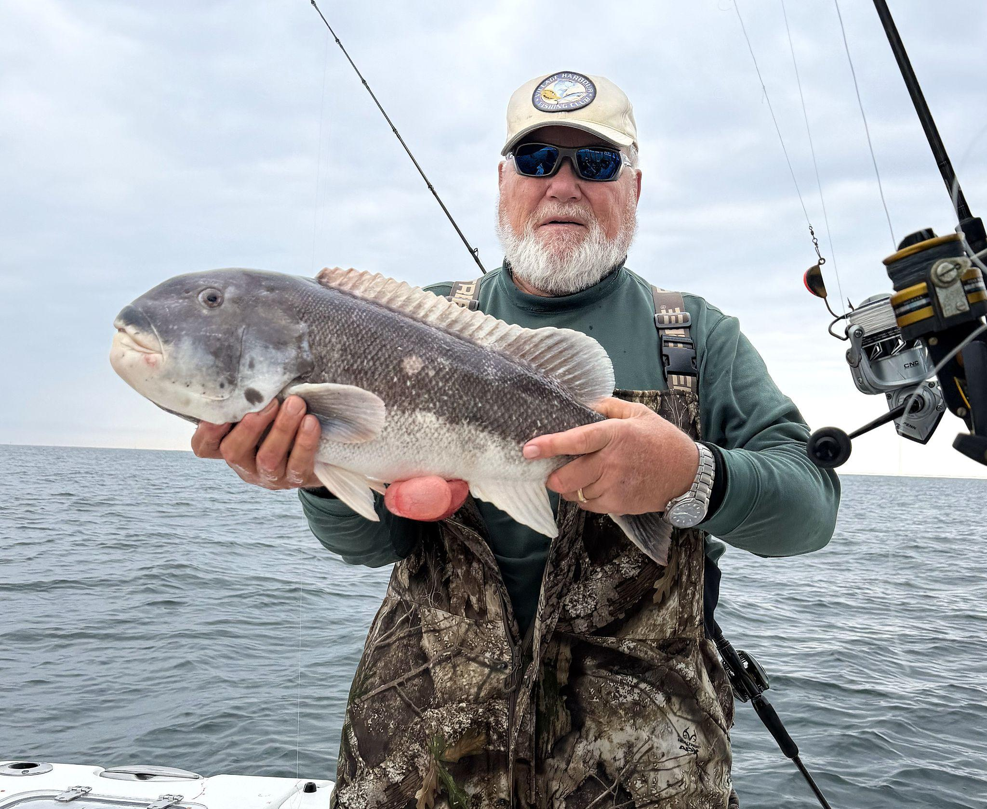
That is a beast! I am referring to the Tog that Marty Friedrich is holding. A 10.5 lb monster Togasaurus that measured 25″ and is now his PB! And Marty released it to grow and become a new PB for someone else. or maybe even for him next year. The Tog was caught on Little Egg Reef.

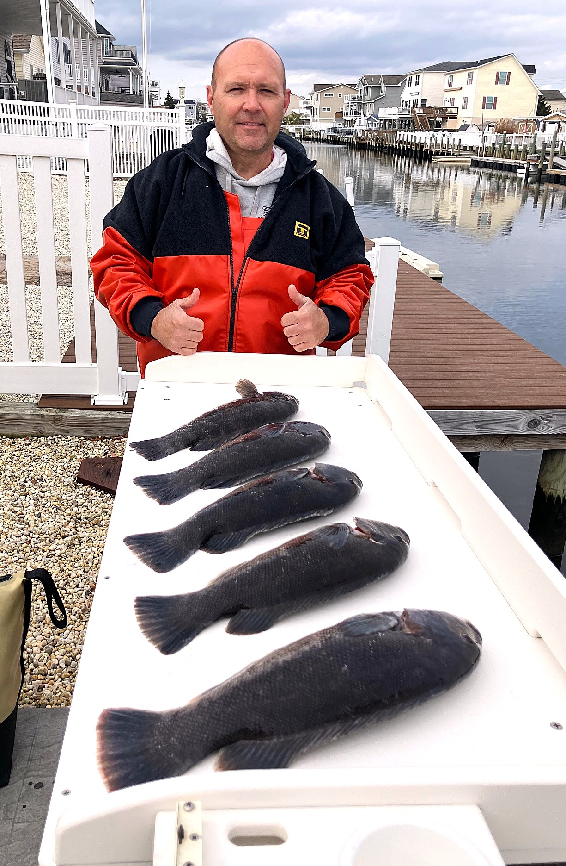
Unable to get anyone to join him, member Drew Kraycirik went out solo for Bass. Unfortunately, all reports were bad.
Plan B was to fish for Tog at the tip of the north jetty – a tough task for one person operating a trolling motor and staying alert. Fortunately, the conditions were perfect, and no one was fishing there. Drew quickly put together his limit of Tog up to 18″.

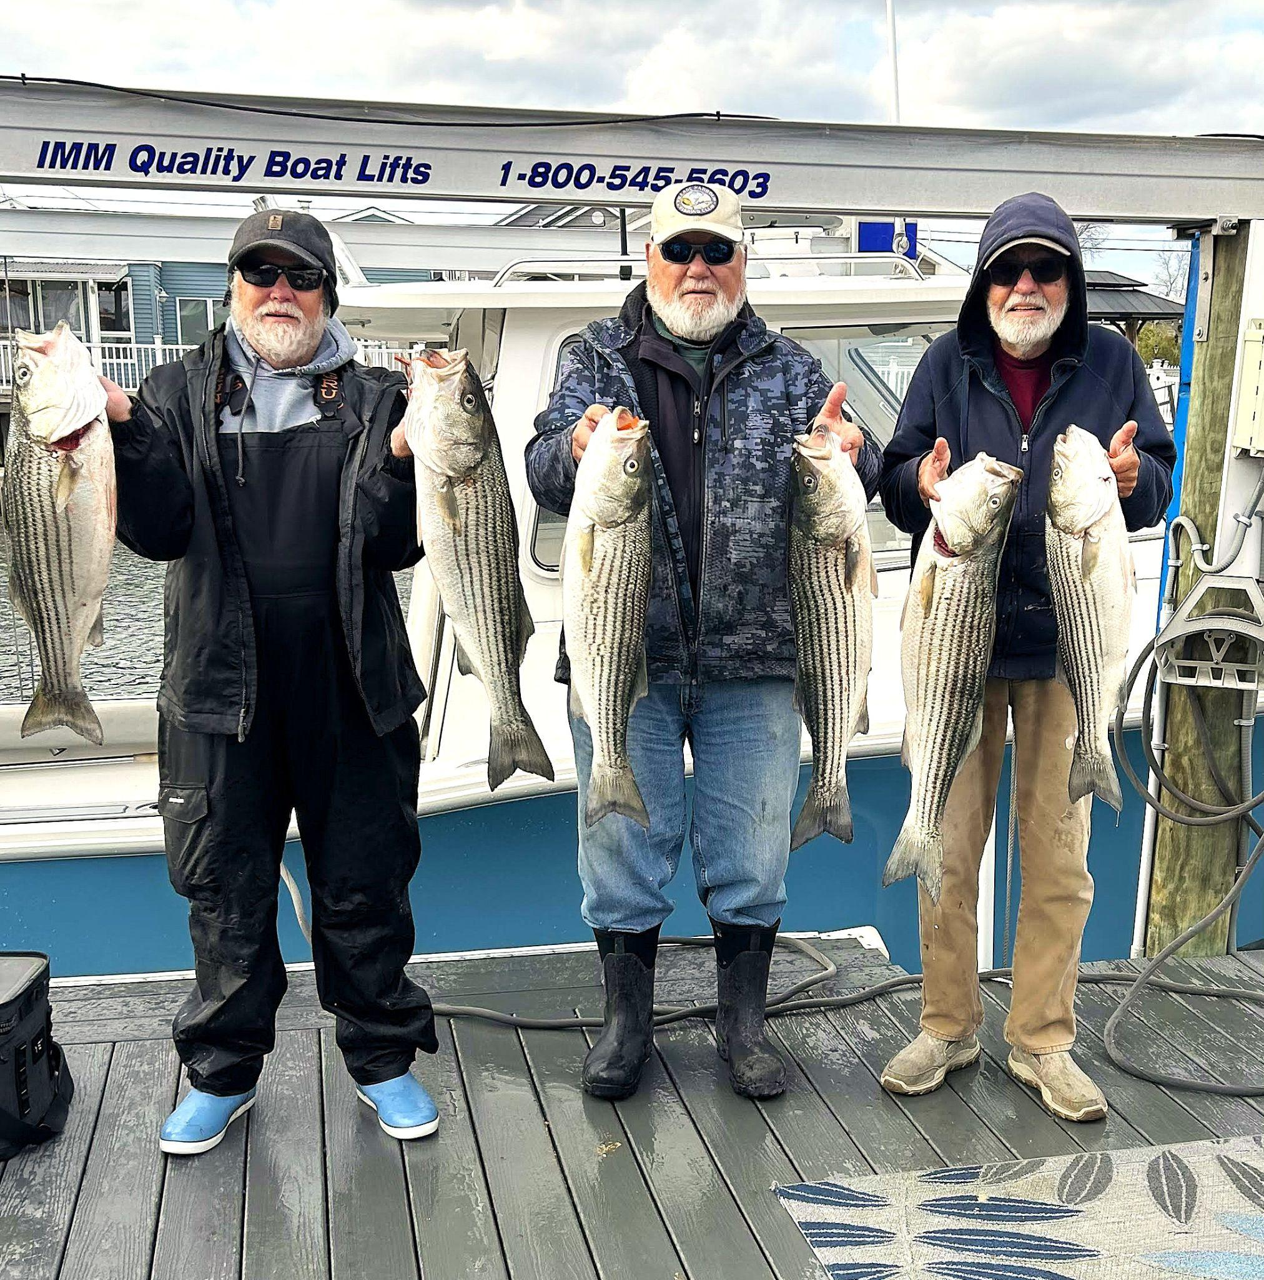

Marty Friedrich was out with Perry and Rick on Rick’s boat for stripers. They were a little north of the radio tower on Beach Haven about two two and a half miles out. The ocean was lettered with birds and stripers were underneath. They each used their tags plus caught their slot fish for six total plus some catch and release!
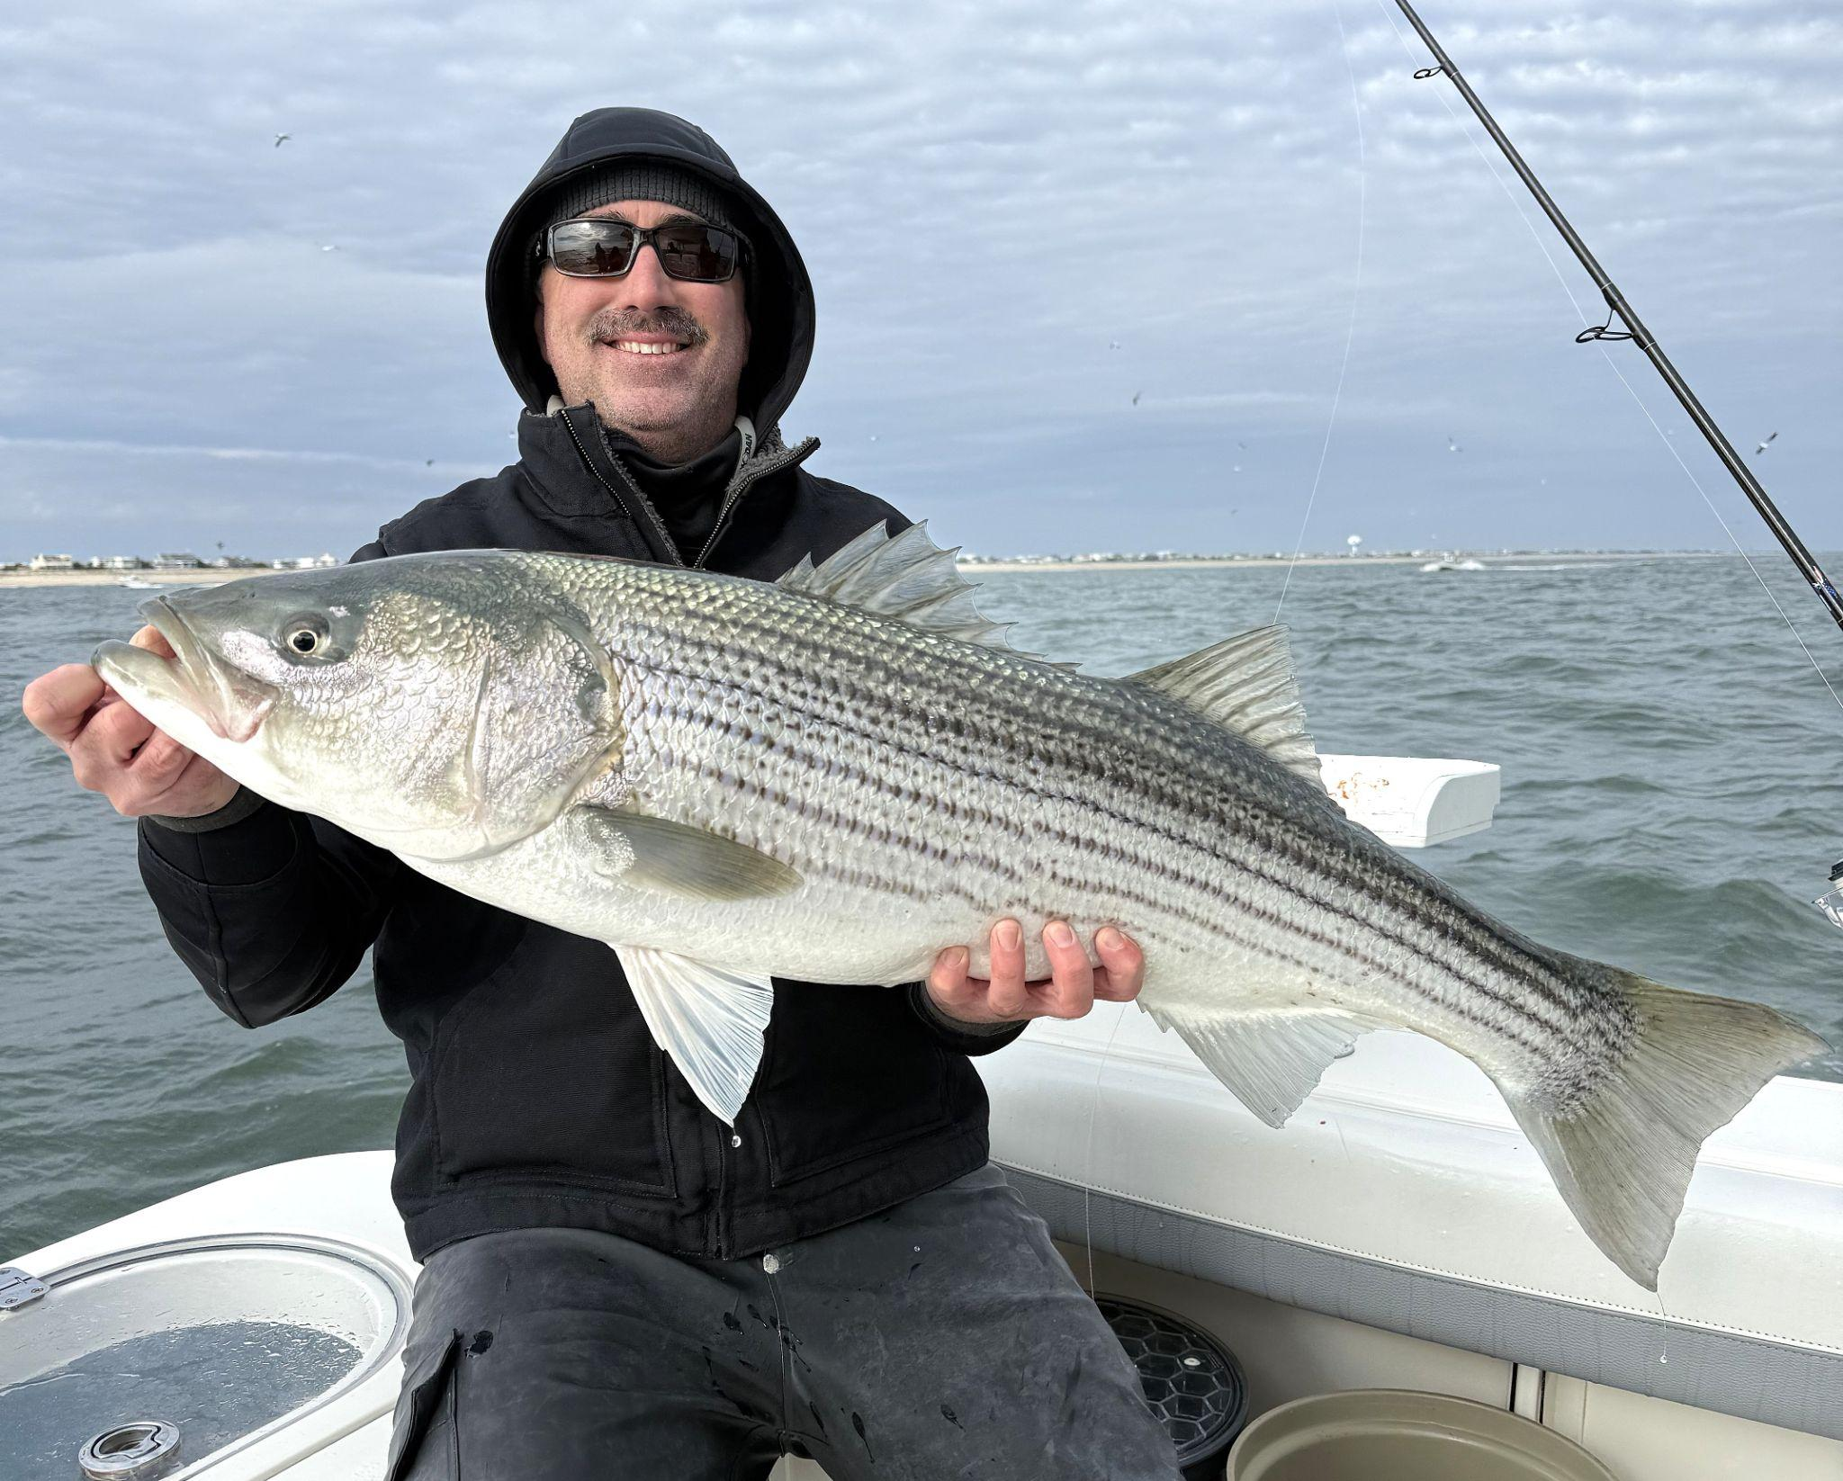

Larry Leary and his Jen-Jen crew - Brian, Tyler, Sean and Bryson - initially were after Stripers but after some tough searching decided to try Tog fishing at GSN. Most wrecks were occupied but they did get several keepers. They then decided to head back north running the beach and luckily, there were large schools of sand eels and plenty of bass. They kept two plus a slot and released a lot.

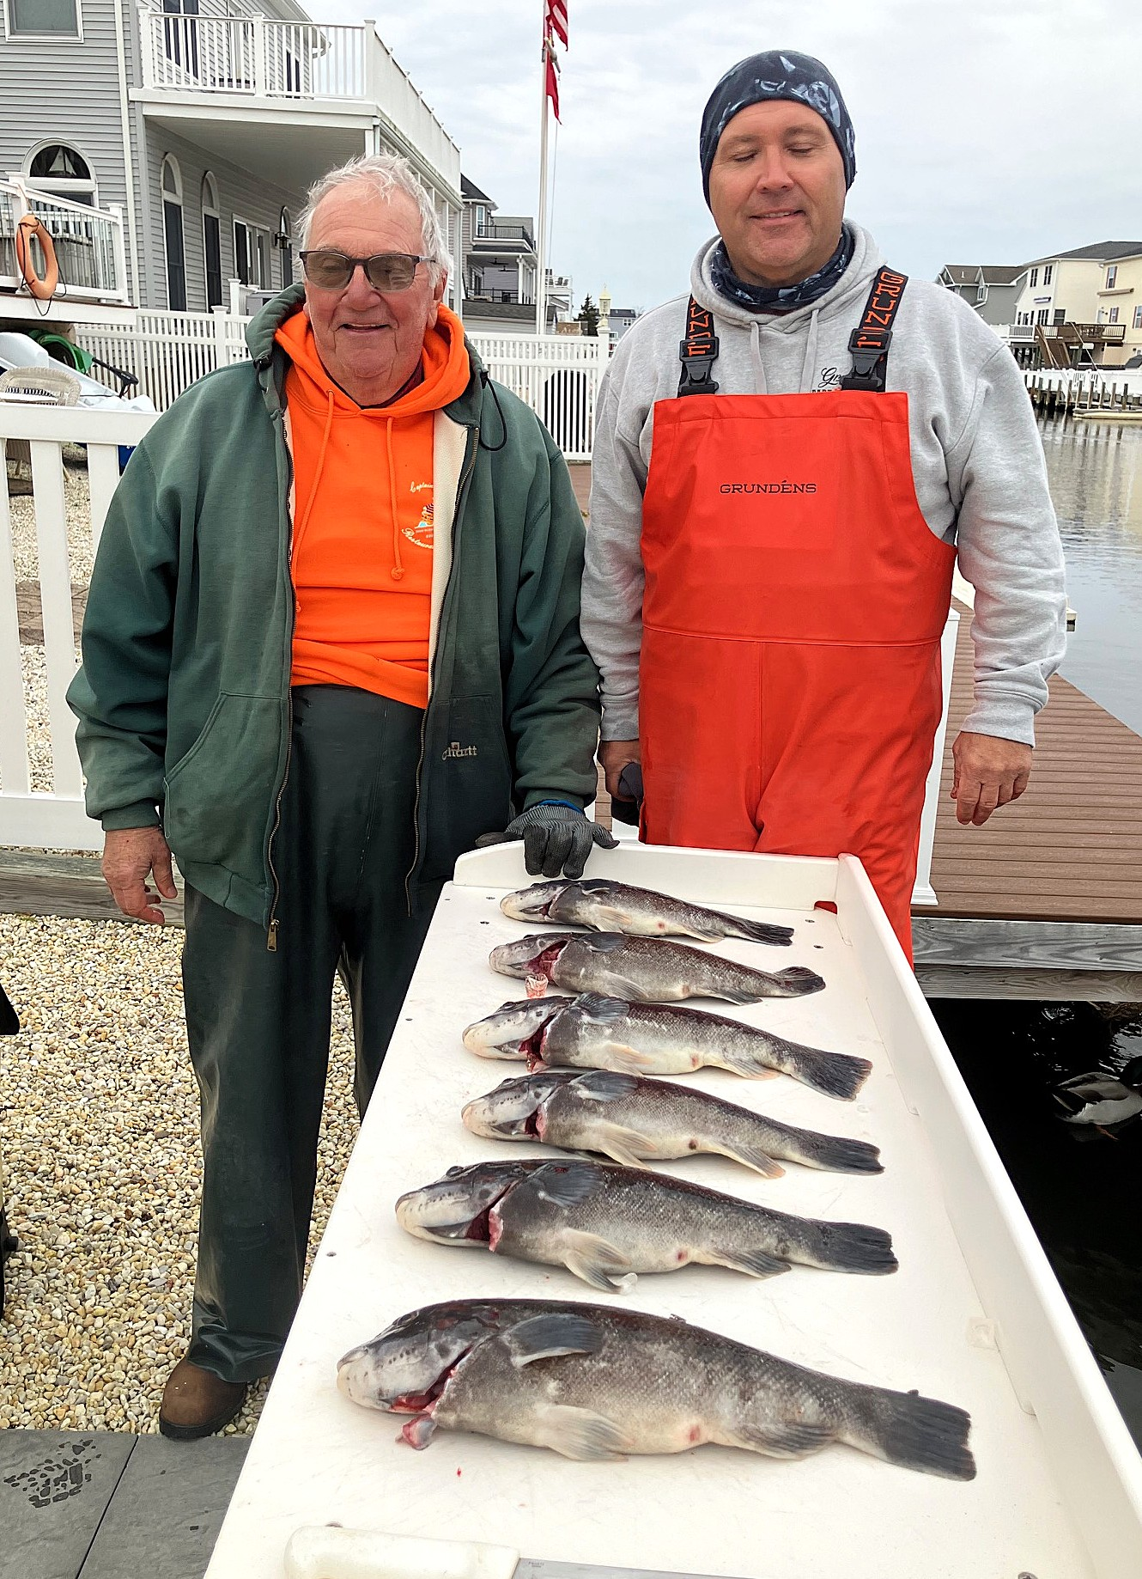

Ed V, Drew Kraycirik and neighbor Anthony aka Rig a Tony went out for Tog and Stripers. Stripers were non-existent so we settled on the tip of the north jetty for Tog. The south wind made fishing difficult, sending waves broadside into us, but it was fishable. We had to weed through many shorts to get our 6 keepers.
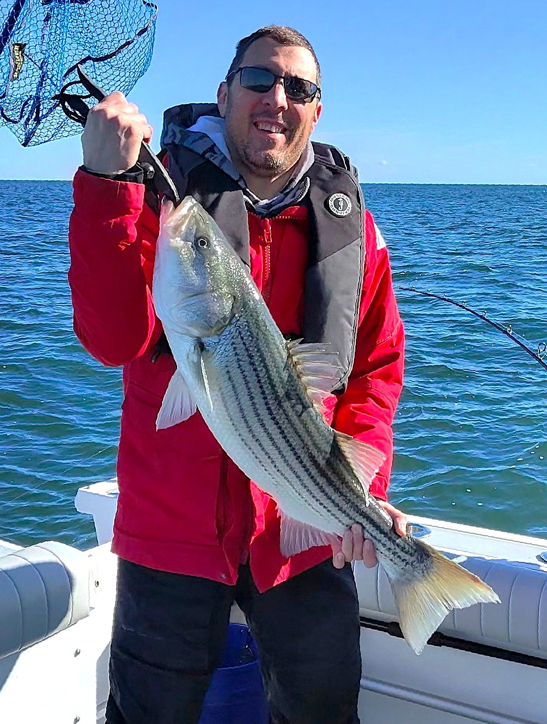

Tim Naples, Bayside Dave and a friend traveled from Tuckerton up to the ‘wheel’. After a couple hours of marking fish and jigging, with no takers, they started trolling with Mojos and umbrellas and ended up boating 9 stripers – 6 overs, 1 under, and 2 keepers.
VHFC Hats by Chuck Dishian - As previously reported, new hats with a khaki cap and dark blue brim with a mesh back were ordered and received. Hats are available at all meetings. Hats will have our logo on them and will be $25. Some original caps are still available for $20 if you prefer. Hats are khaki colored and feature a high definition VHFC patch on the front. They are high quality and available at club meetings. If you would like a hat,come to a meeting to purchase one.
VESSEL SAFETY CHECKS By Jeff Orsoe - Give me a call in the spring for your vessel safety check. Contact: Jeff Orsoe Cell / Text: 732-672-5530 or email: jorsoe786@gmail.com.
CLASSIFIED ADS BUY, SELL or TRADE
Classified ads may be placed free of charge by any club member for non-commercial fishing related items. Please contact Ed Valitutto via email at edvalitutto@gmail.com to place your ad.
FISHING WITH CLUB MEMBERS - Members may place free ads in this section if you wish to find someone to fish with. Maybe you need to find someone with a boat or you are interested in finding someone to share expenses on your boat. With gas prices reaching the sky, helping out with fuel costs is almost a necessity.
USEFUL INFORMATION LINKS
See the full list on our website Links
Wave Information (Height, Period, Direction and Water Temperature) from a Buoy 15 Miles Outside Barnegat Inlet Updated Every 30 minutes: Buoy #44091
Boat/US: http://www.boatus.com/
United States Coast Guard Auxiliary: http://www.cgaux.org/
Notice to Mariners (District 5): http://www.navcen.uscg.gov/?pageName=lnmDistrict&region=5
Fisherman’s Headquarters: http://www.fishermansheadquarters.com/
The Boat Shop: http://theboatshoponline.com/
The Bass Barn: http://www.thebassbarn.com
Barnegat Fishing Hole: http://www.barnegatfishinghole.com/ubbthreads/ubbthreads.php
Animated Knots: http://www.animatedknots.com/
Long Beach Island Water Temperature & Winds: https://seatemperature.info/long-beach-island-water-temperature.html

SPONSORS - The following sponsors offer a discount with the presentation of your current VHFC Membership Card. Discounts normally do not apply to items that are fair traded or items on sale.
BHW Marine Center 10% discount with VHFC card
857 Mill Creek Rd Manahawkin, NJ 08050 609-709-5424

Boat U.S.
Special membership price call Jeff Orsoe. Forms for members’ use will be at VHFC meetings or call Jeff Orsoe 732-672-5530. Also, VHFC members only pay $9.50 for a year of Boat U.S.

Creekside Outfitters 10% discount with VHFC card
403 Rt. 9 Waretown, NJ 08758 609-242-1812

D & S Marine Service 10% discount on parts with VHFC card
460 Dock Rd, West Creek NJ 08092 609-296-0309

Fisherman’s Headquarters 10% discount with VHFC card
280 West 9th St, Ship Bottom, NJ 08008 609-494-5739

Great Bay Outfitters 5% -10% discount with VHFC card
955 Radio Road Little Egg Harbor, New Jersey 609 848 3657

JB Awards 10% discount on engraving and trophies with VHFC card 609-290-5851

Martek Electronics
701 Old Avalon Blvd Unit 4 Avalon, New Jersey 08202 609 390 3355

The Boat Shop 10% discount with VHFC card
756 E. Bay Ave, Manahawkin, NJ 08050 609-597-1271

Scott’s Bait & Tackle 10% discount with VHFC card 609 294 1300

Surf City Bait & Tackle 10% discount with VHFC card
317 Long Beach Blvd, Surf City, NJ 08008 609 994 2333

West Marine - Special discount with VHFC card
424 Rte 9 S, Little Egg Harbor Twp, NJ 08087 609-296-6243

